OIL CONDITION MONITORING REPORT SLNS VIJAYABAHU

GENERATOR PARTICULARS (Information provided by the customer)
 | SSDG (Stbd)
Make : | Electro-Motive Drive
Model : | 8-645E6
Sr. No: | 70-G1-1092
Date sampling : | 27 May 25 | 09 Jun 25
Sampling point : | Lub oil sump
Sampling Method : | Extraction
Type of Lubricant : | Shell Gadinia S3 SAE 40
System Capacity : | 250 US gal

RUNNING HRS DETAILS (Information provided by the customer)
 | SSDG (Stbd)
Sample ID | M010252 | M010253
Oil Running Hours | 8713.35 | 8963.35
After Major routine RH | 23,250.00 | 23,500.00
Total Running Hours of the Machinery | 133,585.40 | 133,835.40

ANALYSIS RESULTS

Description | Method | Uncertainty  (K=2) | Fresh Oil  (As per OEM data sheet) | SSDG (Stbd)
 |  |  |  | M010252 | M010253
Viscosity @ 40ºC (cSt) | ASTM D 445 | 0.006 | 128.00 | 128.38 | 127.18
Viscosity @ 100ºC (cSt) | ASTM D 445 | 0.005 | 13.7 | 13.77 | 13.60
Viscosity Index | ASTM D 2270 | N/A | 103 | 103.60 | 102.51
Total Base No (mgKOH/g) | ASTM D 4739 | 0.77 | 10.48* | N/C | 7.62
Water content (%) | ASTM D 95 | 0.082 | < 0.2 | N/C | <0.1
Flash Point (ºC) | ASTM D 92 | 0.026 | 230 | N/C | 210
* Results were extracted from a fresh oil sample tested at MTTU laboratory as per ASTM D 4739 method.

Elemental Concentration as per ASTM D5185 (ppm)
Element | Maximum Permissible Limit | Fresh Oil Sample | Uncertainty  (K=2) | SSDG (Stbd)
 |  |  |  | M010252 | M010253
Fe | 80 | < 1.000 | 0.15 | 4.946 | 4.550
Cr | 10 | < 1.000 | 0.18 | < 1.000 | < 1.000
Si | 15 | < 1.000 | 0.17 | 3.154
Al | 20 | < 1.000 | 0.28 | < 1.000 | 1.247
Pb | 20 | < 1.000 | 0.13 | 4.906 | 4.589
Cu | 25 | < 1.000 | 0.17 | 13.194 | 13.206
Sn | 10 | < 1.000 | 0.20 | 3.790 | 3.824
Ni | 10 | < 1.000 | 0.08 | < 1.000 | < 1.000

TREND ANALYSIS WITH PREVIOUS REPORTS
 |  | Fresh Oil Sample | SSDG (Stbd)
 |  | Fresh Oil Sample | (S/I-M005483) | (S/I-M005711) | (S/I-M005901) | (S/I-M005967) | (S/I-M006095) | Fresh Oil Sample | (S/I-M006227) | (S/I-M006293) | (S/I-M006473) | (S/I-M006557) | (S/I-M006601) | (S/I-M006696) | S/I-  M006782 | S/I-  M006881 | S/I-  M006990
Oil Running Hrs |  |  | N/I | 1437.45 | 1804.11 | 2023.51 | 250.00 | - | 500.00 | 750.00 | 1000.00 | 1250.00 | 1461.23 | 1711.39 | 1961.25 | 2211.25 | 2461.25
T/R/H of Machinery |  |  | 123696.81 | 124262.00 | 124652.45 | 124872.25 | 125122.40 | - | 125372.25 | 125622.25 | 125,872.2 | 126,122.25 | 126,333.64 | 126,583.64 | 126.833.40 | 127,083.40 | 127333.40
Viscosity @ 40ºC (cSt) |  | 131.49* | 130.08 | 112.33 | 113.99 | 116.63 | 126.48 | 128.00 | 130.42 | 128.24 | 130.51 | 131.06 | 133.30 | 130.85 | 131.47 | 130.81 | 131.22
Viscosity @ 100ºC (cSt) |  | 14.52* | 13.68 | 12.45 | 12.85 | 12.79 | 13.75 | 13.7 | 13.78 | 13.99 | 13.98 | 13.98 | 14.01 | 13.97 | 14.22 | 13.43 | 13.95
Viscosity Index |  | 110.25 | 100.76 | 101.92 | 106.02 | 102.1 | 105.22 | 103 | 101.75 | 106.63 | 104.28 | 102.23 | 102.048 | 103.82 | 106.44 | 97.12 | 103.21
Total Base No. mgKOH/g |  | 9.02* | 9.46 | N/C | N/C | N/C | N/C | 10.48* | N/C | N/C | N/C | N/C | N/C | N/C | N/C | N/C | N/C
Water content% |  | < 0.2 | 190 | N/C | N/C | N/C | N/C | < 0.2 | N/C | N/C | N/C | N/C | N/C | N/C | N/C | N/C | N/C
Flash Point (ºC) |  | 220* | <0.1 | N/C | N/C | N/C | N/C | 230 | N/C | N/C | N/C | N/C | N/C | N/C | N/C | N/C | N/C
Elemental Concentration as per ASTM D5185 (ppm)
Element | Max. Permissible
Fe | 80 | < 1.000 | 7.191 | 6.941 | 6.439 | 7.039 | 4.010 | < 1.000 | 6.971 | 4.825 | 2.623 | 4.233 | 3.911 | 4.401 | 8.018 | 4.243 | 6.924
Cr | 10 | < 1.000 | 1.078 | < 1.000 | < 1.000 | < 1.000 | < 1.000 | < 1.000 | 7.386 | < 1.000 | < 1.000 | < 1.000 | < 1.000 | < 1.000 | < 1.000 | < 1.000 | 1.126
Si | 15 | < 1.000 | 7.595 | 3.863 | 8.403 | 6.703 | 9.134 | < 1.000 | 2.305 | 6.394 | 3.429 | < 1.000 | 1.757 | 3.506 | 5.257 | 6.170 | 5.753
Al | 20 | < 1.000 | 2.175 | 3.137 | < 1.000 | < 1.000 | 4.950 | < 1.000 | 2.574 | 3.204 | 2.072 | < 1.000 | 1.22 | 1.222 | 2.320 | 1.263 | 3.294
Pb | 20 | < 1.000 | 4.773 | 26.374 | 40.905 | 23.760 | 4.473 | < 1.000 | < 1.000 | 4.047 | 3.300 | 36.811 | 3.39 | 4.391 | 4.398 | 6.278 | 5.074
Cu | 25 | < 1.000 | 11.398 | 17.578 | 22.814 | 21.810 | 2.751 | < 1.000 | < 1.000 | 8.793 | 3.108 | 11.739 | 9.45 | 9.608 | 20.846 | 11.619 | 11.483
Sn | 10 | < 1.000 | 2.671 | 3.162 | 3.216 | 2.948 | 1.041 | < 1.000 | < 1.000 | 1.832 | 3.445 | 2.246 | 2.87 | 2.308 | 3.498 | 3.692 | 3.986
Ni | 10 | < 1.000 | < 1.000 | N/A | N/A | N/A | N/A | < 1.000 | < 1.000 | N/A | < 1.000 | < 1.000 | < 1.000 | N/A | < 1.000 | < 1.000 | < 1.000

 |  | SSDG (Stbd)
 |  | Fresh Oil Sample | S/I- M007006 | S/I- M007108 | S/I- M007232 | S/I- M007254 | S/I- M007376 | S/I- M007735 | S/I- M007919 | S/I- M008039 | S/I- M008323 | S/I- M008375 | S/I- M008513 | S/I- M008682 | S/I- M008783 | S/I- M008821 | S/I- M008940
Oil Running Hrs |  |  | 2711.25 | 3,111.15 | 3361.15 | 3611.15 | 3861.15 | 4211.15 | 4463.15 | 4713.15 | 4963.35 | 5213.35 | 5,463.35 | 5713.35 | 5963.35 | 6,213.35 | 6463.35
T/R/H of Machinery |  |  | 127,583.40 | 128,083.40 | 128333.40 | 128583.40 | 128833.40 | 129083.40 | 129335.40 | 129585.40 | 129835.40 | 130085.40 | 130,335.4 | 130585.40 | 130,835.40 | 131,085.40 | 131,335.40
Viscosity @ 40ºC (cSt) |  | 128.00 | 127.02 | 130.72 | 134.54 | 133.32 | 126.84 | 130.82 | 130.55 | 126.83 | 133.64 | 129.75 | 130.59 | 128.97 | 129.15 | 130.34 | 129.10
Viscosity @ 100ºC (cSt) |  | 13.7 | 13.79 | 13.88 | 14.59 | 14.38 | 13.81 | 14.16 | 14.05 | 13.80 | 14.40 | 14.02 | 14.14 | 14.03 | 14.10 | 14.15 | 14.08
Viscosity Index |  | 103 | 105.21 | 102.80 | 108.18 | 107.48 | 105.69 | 106.31 | 105.16 | 105.567 | 106.62 | 105.55 | 106.28 | 106.45 | 107.18 | 106.65 | 106.96
Total Base No. mgKOH/g |  | 10.48* | 9.22 | 9.03 | 9.14 | 9.15 | 9.27 | 9.17 | 9.10 | 8.32 | 7.61 | 7.70 | 7.65 | 7.80 | 7.86 | 7.94 | 7.56
Water content% |  | < 0.2 | < 0.1 | < 0.1 | <0.1 | < 0.1 | < 0.1 | < 0.1 | < 0.1 | < 0.1 | < 0.1 | 220 | 218 | 214 | 212 | 210 | 210
Flash Point (oC) |  | 230 | 190 | 190 | 190 | 190 | 195 | 200 | 200 | 218 | 226 | < 0.1 | < 0.1 | < 0.1 | < 0.1 | < 0.1 | <0.1
Elemental Concentration as per ASTM D5185 (ppm)
Element | Max. Permissible
Fe | 80 | < 1.000 | 9.333 | 6.579 | 7.539 | 7.343 | 6.463 | 6.144 | 6.661 | 7.088 | 6.407 | 6.637 | 6.426 | 4.865 | 6.748 | 6.659 | 5.287
Cr | 10 | < 1.000 | < 1.000 | < 1.000 | 1.346 | 1.064 | < 1.000 | < 1.000 | < 1.000 | 1.099 | < 1.000 | 1.130 | < 1.000 | < 1.000 | < 1.000 | < 1.000 | < 1.000
Si | 15 | < 1.000 | 5.475 | 4.912 | 2.214 | 3.914 | 2.644 | 3.153 | 1.603 | 1.382 | 1.785 | 1.948 | 4.166 | 2.351 | 1.363 | 3.918 | 2.369
Al | 20 | < 1.000 | 2.842 | < 1.000 | < 1.000 | < 1.000 | 1.407 | < 1.000 | 1.198 | 1.117 | 1.715 | < 1.000 | < 1.000 | < 1.000 | 1.312 | 1.371 | 1.211
Pb | 20 | < 1.000 | 4.062 | 4.068 | 4.789 | 4.616 | 4.199 | 4.912 | 4.062 | 4.797 | 4.394 | 4.692 | 4.331 | 3.613 | 3.638 | 4.252 | 3.980
Cu | 25 | < 1.000 | 12.823 | 11.422 | 19.775 | 15.672 | 7.392 | 11.434 | 10.113 | 11.636 | 10.046 | 10.436 | 12.942 | 8.698 | 10.156 | 10.913 | 10.116
Sn | 10 | < 1.000 | 2.232 | 2.585 | 3.264 | < 1.000 | 1.871 | 3.750 | 3.350 | 1.294 | 3.422 | 3.885 | 3.957 | 3.732 | 2.927 | 3.621 | 3.748
Ni | 10 | < 1.000 | < 1.000 | < 1.000 | < 1.000 | < 1.000 | < 1.000 | < 1.000 | < 1.000 | < 1.000 | < 1.000 | < 1.000 | < 1.000 | < 1.000 | < 1.000 | < 1.000 | < 1.000

 |  | SSDG (Stbd)
 |  | Fresh Oil Sample | S/I- M009034 | S/I- M009035 | S/I- M009049 | S/I- M009197 | S/I- M009301 | S/I- M009388 | S/I- M009522 | S/I- M009644 | S/I- M009848 | S/I- M010252 | S/I- M010253
Oil Running Hrs |  |  | 6,713.35 | 6,863.35 | 6963.35 | 7213.35 | 7,463.35 | 7,713.35 | 7963.35 | 8,213.35 | 8,463.35 | 8713.35 | 8963.35
T/R/H of Machinery |  |  | 131,585.40 | 131,735.40 | 131,835.40 | 132,085.40 | 132,335.40 | 132,585.40 | 132835.40 | 133,085.40 | 133,335.40 | 133,585.40 | 133,835.40
Viscosity @ 40ºC (cSt) |  | 128.00 | 128.79 | 127.02 | 126.98 | 126.13 | 127.16 | 127.61 | 129.19 | 128.90 | 127.95 | 128.38 | 127.18
Viscosity @ 100ºC (cSt) |  | 13.7 | 14.30 | 13.98 | 13.66 | 13.52 | 13.66 | 14.06 | 13.85 | 13.78 | 13.68 | 13.77 | 13.60
Viscosity Index |  | 103 | 110.10 | 107.75 | 103.54 | 102.497 | 103.26 | 108.20 | 103.86 | 103.25 | 102.82 | 103.60 | 102.51
Total Base No. mgKOH/g |  | 10.48* | 7.34 | 7.58 | 7.62 | 7.64 | 7.77 | 7.86 | 7.35 | 7.48 | 7.41 | N/C | 7.62
Water content% |  | < 0.2 | < 0.1 | < 0.1 | < 0.1 | <0.1 | <0.1 | <0.1 | <0.1 | <0.1 | <0.1 | N/C | <0.1
Flash Point (oC) |  | 230 | 216 | 214 | 214 | 218 | 216 | 210 | 210 | 208 | 208 | N/C | 210
Elemental Concentration as per ASTM D5185 (ppm)
Element | Max. Permissible Limit
Fe | 80 | < 1.000 | 9.333 | 8.000 | 5.045 | 6.611 | 6.088 | 5.391 | 5.319 | 5.599 | 7.284 | 4.946 | 4.550
Cr | 10 | < 1.000 | < 1.000 | 1.950 | < 1.000 | 1.444 | < 1.000 | < 1.000 | < 1.000 | < 1.000 | < 1.000 | < 1.000 | < 1.000
Si | 15 | < 1.000 | 5.475 | 3.539 | < 1.000 | < 1.000 | < 1.000 | 2.063 | 2.276 | 2.492 | 1.024 | 3.154
Al | 20 | < 1.000 | 2.842 | 1.171 | 1.032 | 1.283 | < 1.000 | 1.344 | 1.152 | 1.006 | 3.569 | < 1.000 | 1.247
Pb | 20 | < 1.000 | 4.062 | 4.299 | 3.212 | 4.310 | 4.540 | 3.654 | 4.025 | 3.360 | 4.601 | 4.906 | 4.589
Cu | 25 | < 1.000 | 12.823 | 12.055 | 10.198 | 11.155 | 9.370 | 9.381 | 13.892 | 10.176 | 10.192 | 13.194 | 13.206
Sn | 10 | < 1.000 | 2.232 | 3.749 | 2.691 | 4.006 | 3.035 | 4.025 | 3.179 | 3.433 | 2.906 | 3.790 | 3.824
Ni | 10 | < 1.000 | < 1.000 | < 1.000 | < 1.000 | < 1.000 | < 1.000 | < 1.000 | < 1.000 | < 1.000 | < 1.000 | < 1.000 | < 1.000

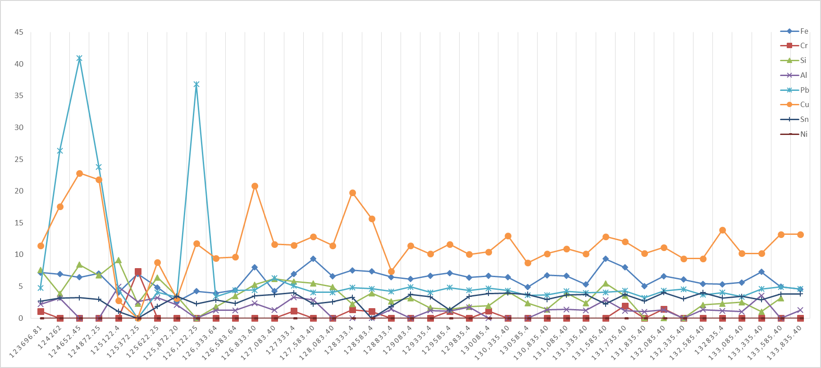
Wear Metals

ppm
Total running Hours

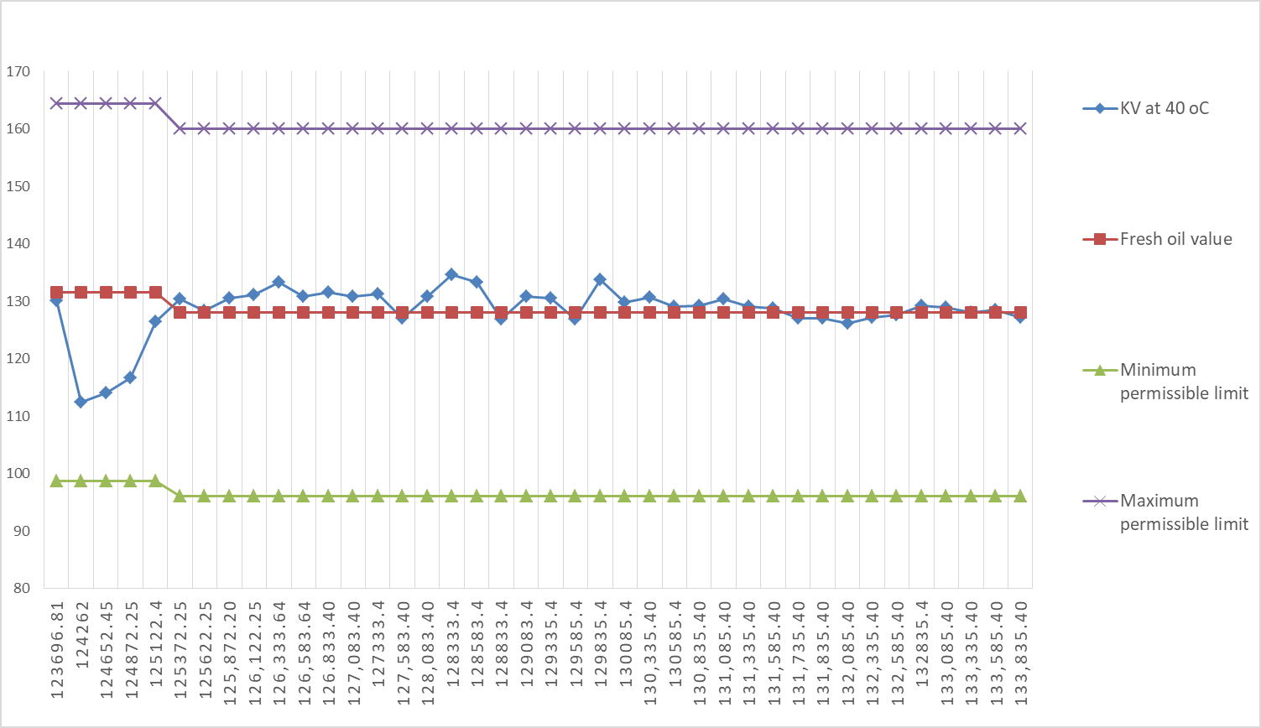
Viscosity
40⁰C

cSt

Total running Hours
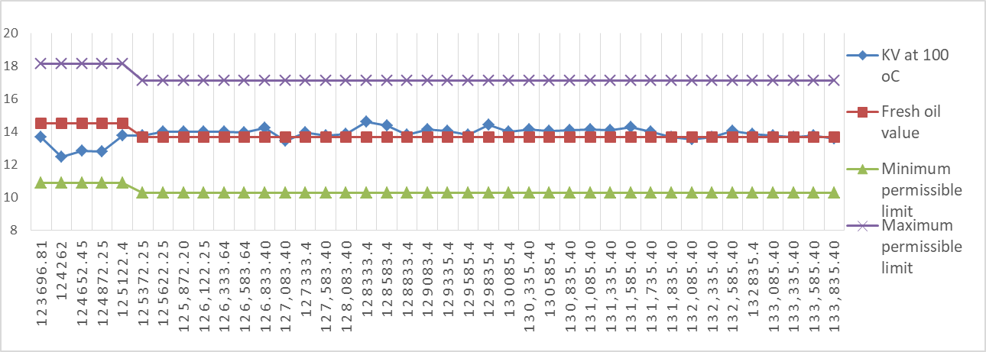
100⁰C

cSt

Total running Hours

